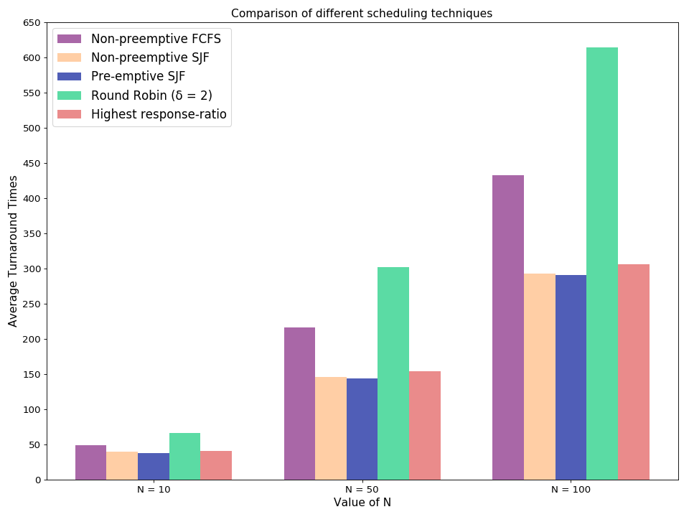
Generated Plot

The above plot is generated by the following python script:

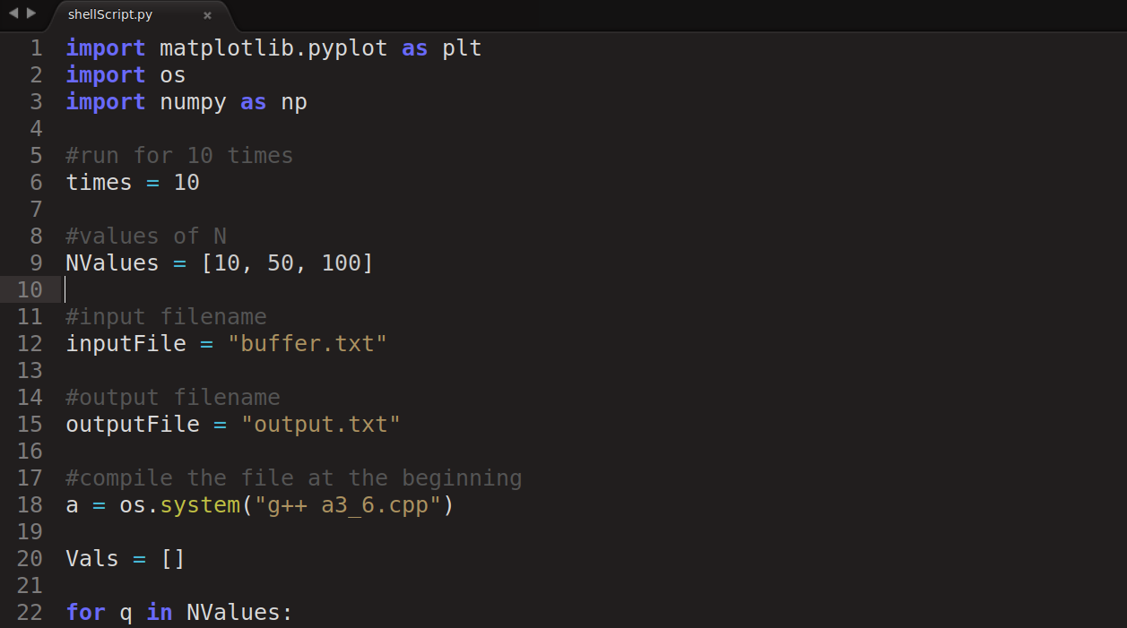

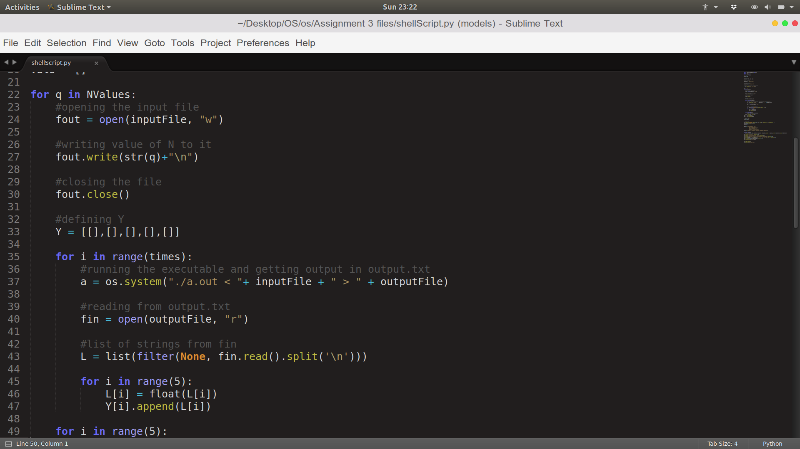
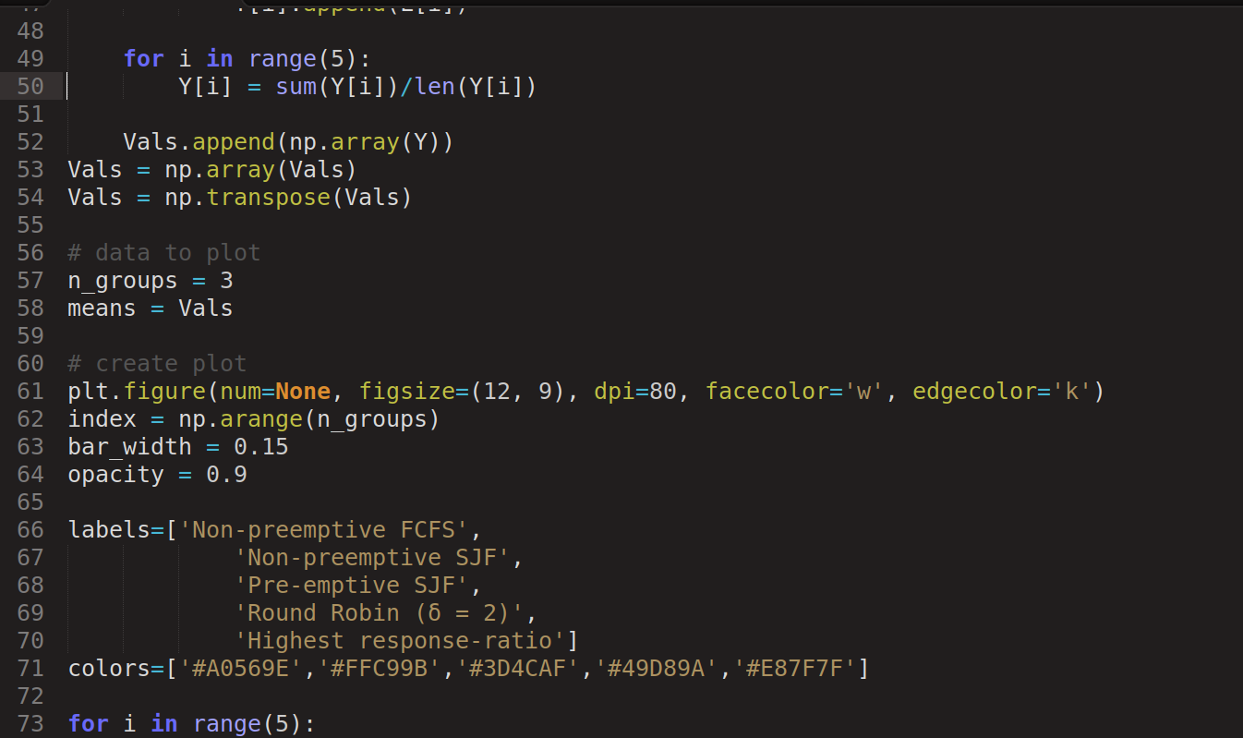

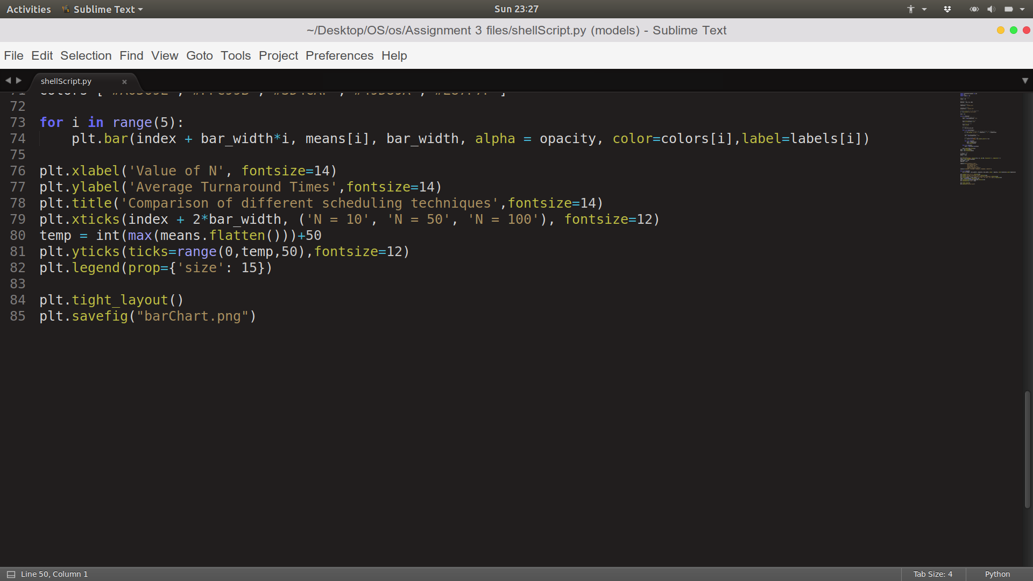

Theoretical Analysis of Non-preemptive FCFS scheduling algorithm:
(Determination of Theoretically expected lower bound on the turn-around time)

Turn Around Time for some Process
= Process’s Completion Time – Process’ Arrival Time
= Process’s Waiting Time + Process’s CPU Burst

To get a theoretical lower bound, we consider the best case in which the waiting time for each process will be zero and hence turn around time for each process will be its CPU burst. Let Y_{i} be the CPU Burst of the i-th process

Hence, Expected value of lower bound

= E((Σ_{i=1 to N} (Y_{i} )) / N)

= (Σ_{i=1 to N} E(Y_{i})) / N

= E(Y)

= 10.5 [ as Y is a uniform random variable between 1 and 20 ]

And we checked, that, this lower bound is satisfied by our simulation.

